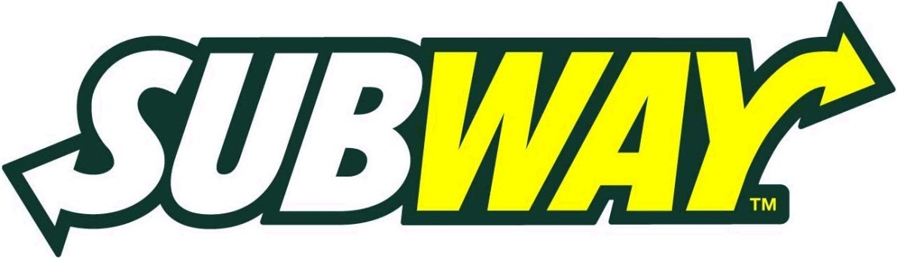
Together we eat Subway to support the 2017 Associates Campaign!
What: 15% Back to 2017 Associates Campaign
When: Friday, May 5, 2017 11:00 am – 1:00 pm
Friday, May 19, 2017 11:00 am – 1:00 pm

Where: Subway - Professional Office Building
8402 Harcourt Rd., Indianapolis, IN 46260

Why: To give back to the patients and families served by St.Vincent!
Proceeds will benefit the outdoor associate break area, the selected project for the 2017 Associates Campaign.*
*Applicable only at 8402 Harcourt Rd. location.

