Name
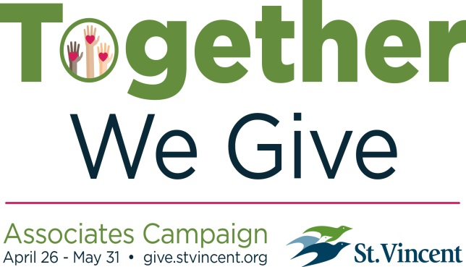
Associate ID (First 8 digits on back of ID badge)

PO Business Unit Department ID
5 digits begins with 460XX 5 digit Cost Center

Home Address

City, State, Zip

Phone E-mail

Name(s) to Appear on Donor Listings

Shirt Size (Provided with gift/pledge of $250+) Anonymous Gift
2017 Associates Campaign • April 26 - May 31 • give.stvincent.org/together

Designation
Indianapolis: Outdoor Associate Break Area
Other _____________________________________

Contribution
I would like to make a:

Pledge of $_____________ to be paid over 1 year 2 years 3 years Other________
(26 pays) (52 pays) (78 pays)

Payroll Deduction. Please make deductions of $ _________________ per pay period. (Minimum of $1/pay period.)
Signature for Payroll Authorization ________________________________________________.
____ Please start my deduction as soon as possible.
____ Please start my deduction with the new fiscal year. Deductions will begin 7/21/17.

Invoice Me. Monthly Quarterly Annually (Invoices will be mailed 1 month prior.)

The first pledge payment is enclosed will be paid on _____________________.
Date
Gift of $________________.
Check (payable to St.Vincent Foundation)
Cash
Credit Card
One-time contribution
Recurring monthly contribution
Name on card
Card # Exp.
Signature

Honor/Memory
Please make this gift in Honor of Memory of __________________________________________________________

Name and address of person to notify (optional)

Recognition
I would like to opt out of receiving Campaign gifts.

• All Donors Campaign bracelet
• $136+ Above, plus Campaign charm
• $250+ Above, plus Campaign t-shirt (size requests fulfilled in order contributions are received)
• $500+ Above, plus St. Vincent lunch bag
• $1,000+ Above, plus Friends of the Foundations benefits, including cafeteria discounts

Return this form to St.Vincent Foundation, 8402 Harcourt Road, Suite 210, Indianapolis, IN 46260.
Visit give.stvincent.org/together to contribute online. Questions? Call (317) 338-2338.

